**NAME:Snigdha Singh                                                                                  REG.NO.:20BCE0545**

**DATA ANALYTICS: Major Port Traffic And Capacity Analytics Using IBM Cognos Analytics**

**1)Data Upload and Data Preperation**

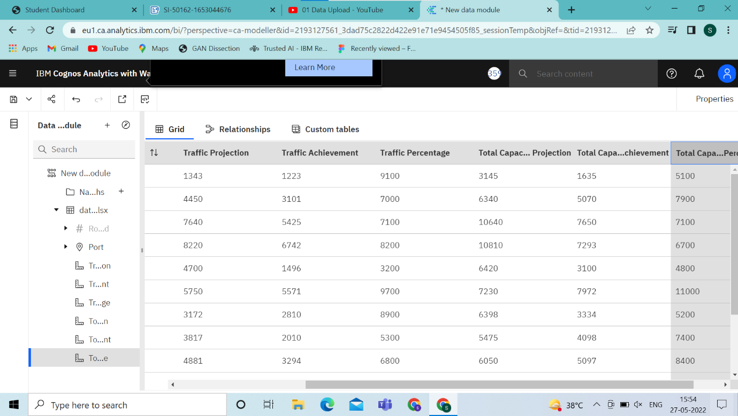

->I went to ibm.com logged in using my credentials and launched data analytics using watson and pressed on the upload data option

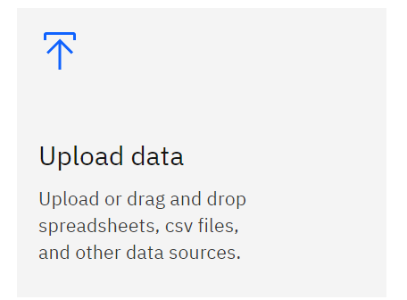

->I selected the dataset I wanted (dataset.xslx)

->Next we renamed the columns as given in the project details to rename we selected the three dots and go to the rename option and rename it to whatever we want similarly we need to do it for all the columns

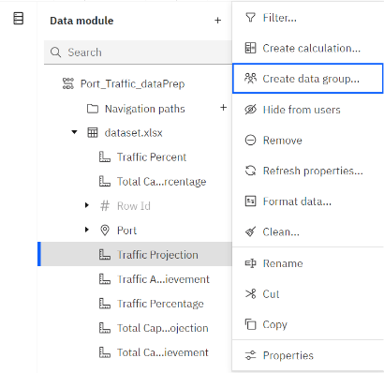

**2)Preparing Calculations**

i. Traffic Percentage   as

**Traffic Achievement  /  Traffic Projection**

ii. Total Capacity Percentage as

**Total Capacity Achievement / Total Capacity Projection**

To do this we need to go to the new module option and right click here then press on calculation option

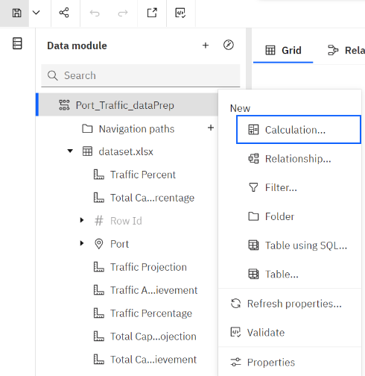

In the calculation option include the columns that are required for the calculation (drag and drop) and then rename the new column at the end validate the calculation and the press create

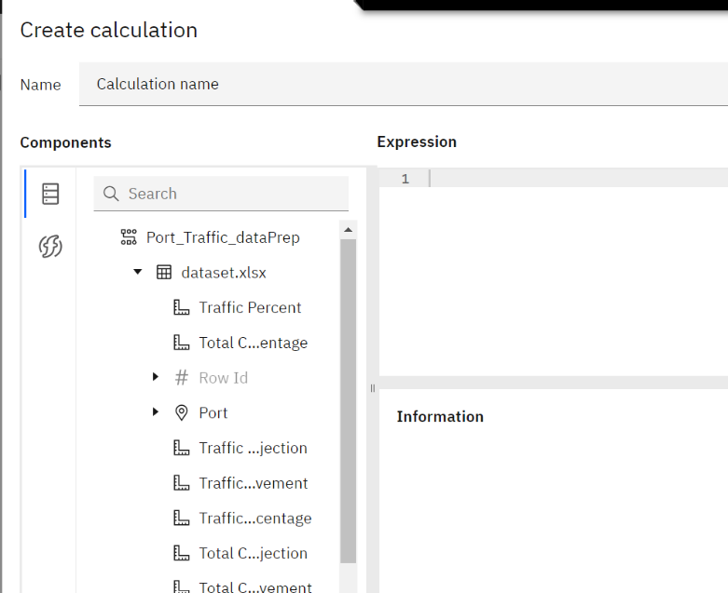

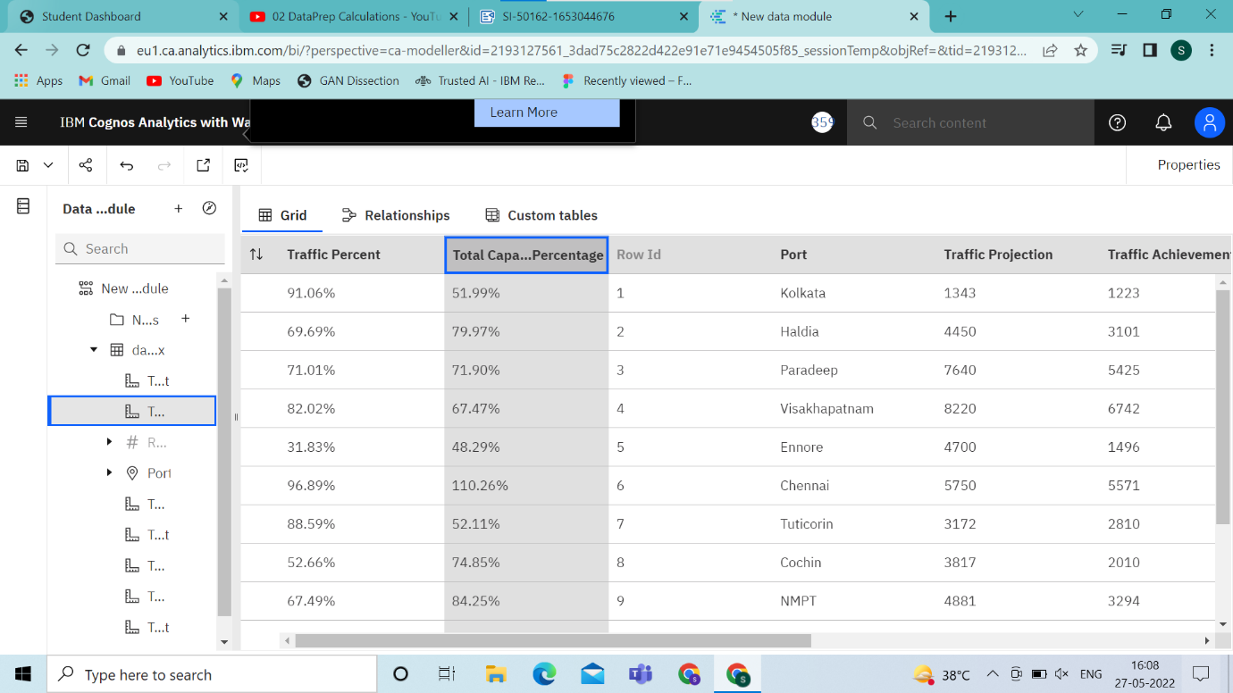

**How to make visualizations**

->Go to Present data option and select the dashboard

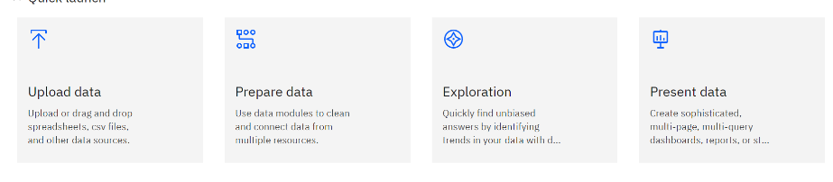

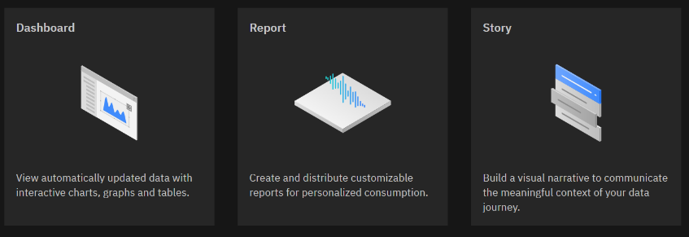

->Then go from the type of dashboard select the one suitable for your visualisation

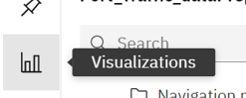

->After selecting the visualization to be used add the columns based on utility to all the blanks in the visualizations

->Go to properties option to add any new properties to the respective charts and you will have the final result

**Port wise Traffic and Capacity Distribution**

Link to DashBoard: <https://eu1.ca.analytics.ibm.com/bi/?perspective=dashboard&pathRef=.my_folders%2FPort%2Bwise%2BCapacity%2Band%2BTraffic&action=view&mode=dashboard&subView=model00000181051e1691_00000000>

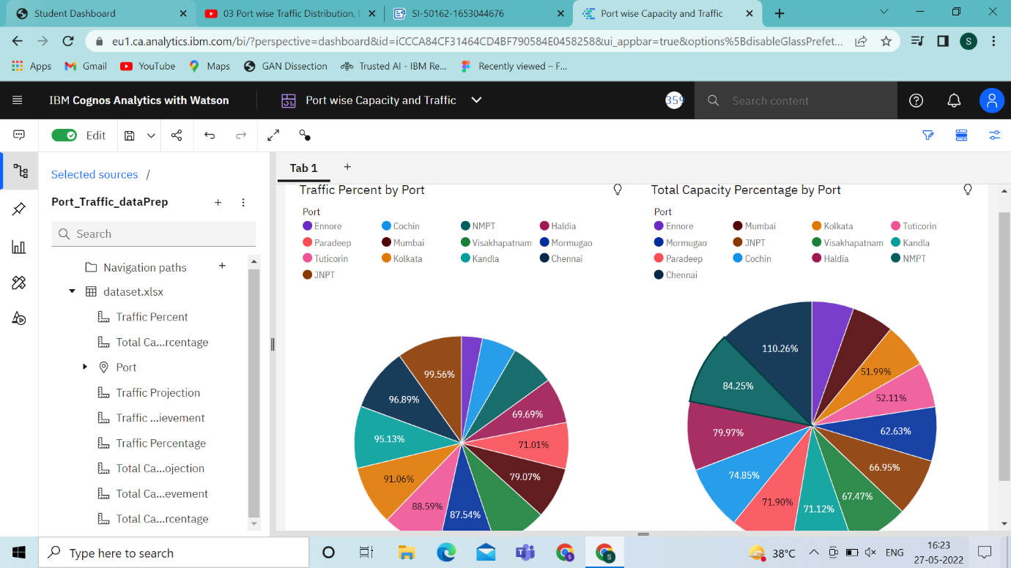

**Port-Wise Traffic Vs Capacity By Line Chart**

**Link to dashboard:**

https://eu1.ca.analytics.ibm.com/bi/?perspective=dashboard&pathRef=.my_folders%2FPort%2Bwise%2BCapacity%2Band%2BTraffic&action=view&mode=dashboard&subView=model000001810527bd28_00000000

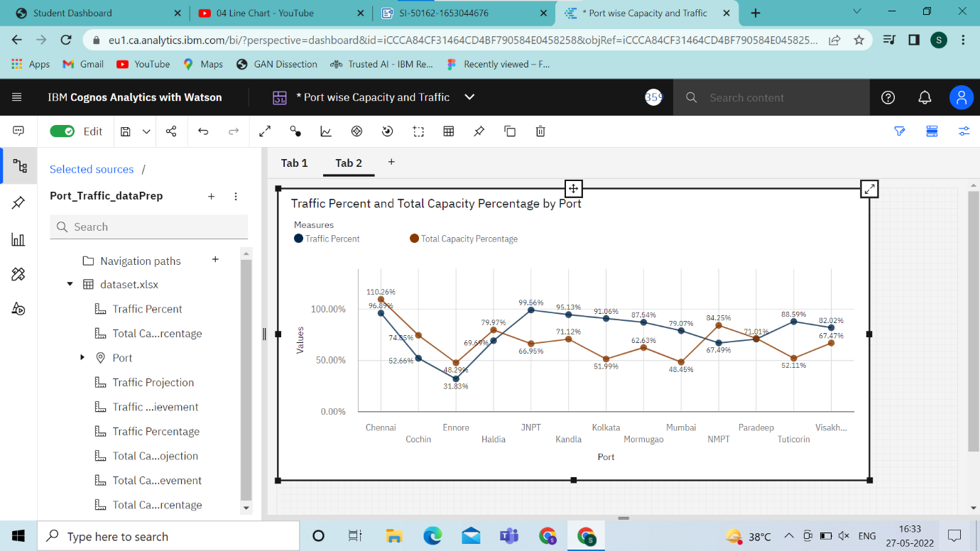

**Port-Wise Traffic Projected Vs Achieved By Column Chart**

Link to dashboard:https://eu1.ca.analytics.ibm.com/bi/?perspective=dashboard&pathRef=.my_folders%2FPort%2Bwise%2BCapacity%2Band%2BTraffic&action=view&mode=dashboard&subView=model0000018105312937_00000000

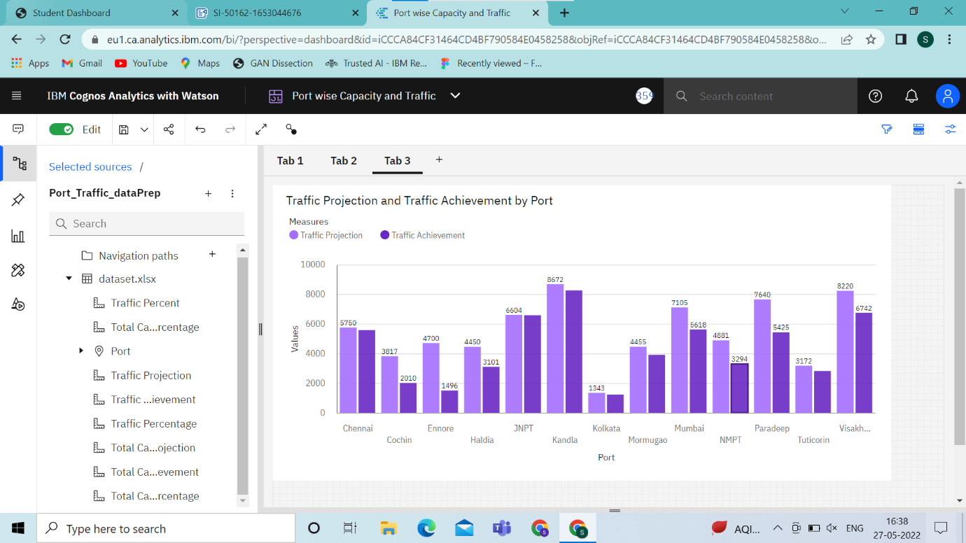

**Port-Wise Traffic Projected Vs Achieve By Stacked Column Chart**

Link to dashboard:https://eu1.ca.analytics.ibm.com/bi/?perspective=dashboard&pathRef=.my_folders%2FPort%2Bwise%2BCapacity%2Band%2BTraffic&action=view&mode=dashboard&subView=model0000018105376132_00000000

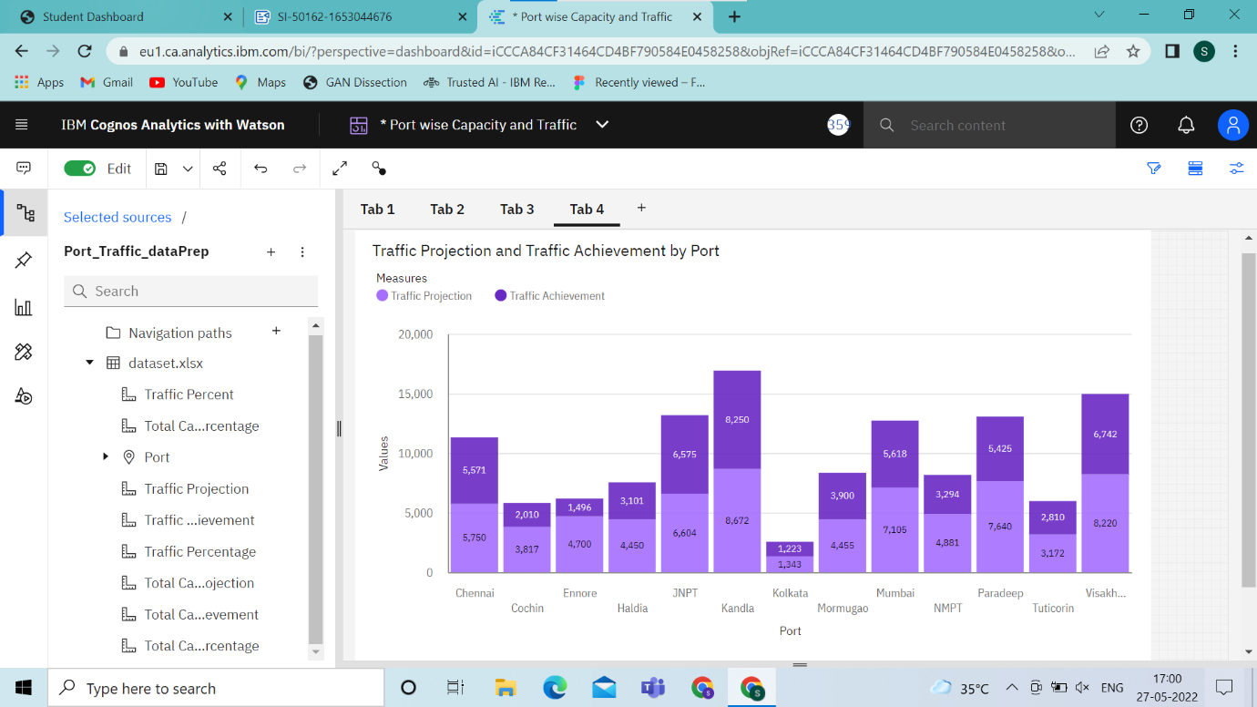

**Port-Wise Total Capacity Projects Vs Total Capacity Achieve By Line And Bar Chart**

**Link to dashboard:**https://eu1.ca.analytics.ibm.com/bi/?perspective=dashboard&pathRef=.my_folders%2FPort%2Bwise%2BCapacity%2Band%2BTraffic&action=view&mode=dashboard&subView=model000001810549a691_00000000

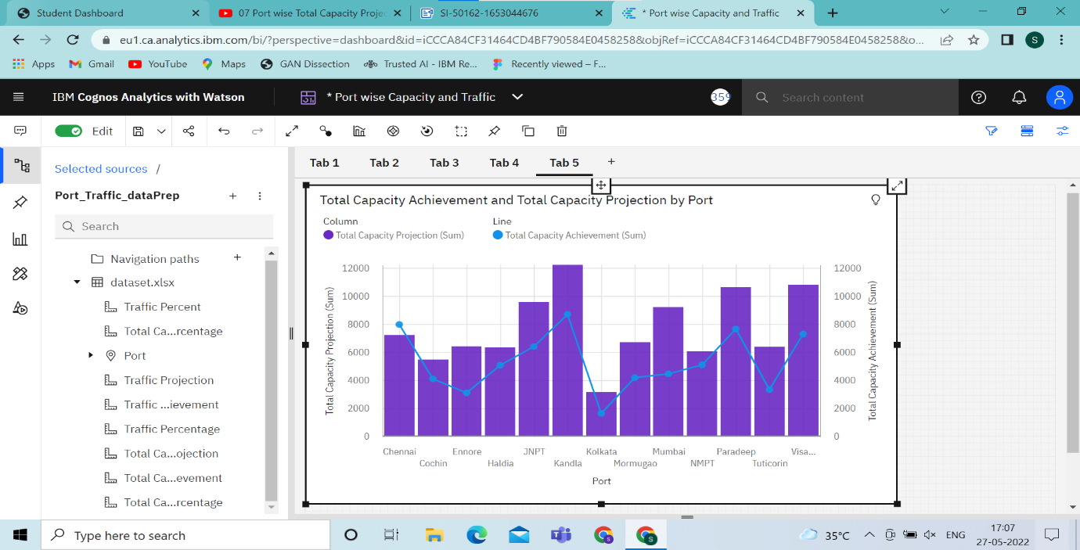

**Port-Wise Traffic Projects Vs Total Projected By Area Chart**

Link to dashboard:https://eu1.ca.analytics.ibm.com/bi/?perspective=dashboard&pathRef=.my_folders%2FPort%2Bwise%2BCapacity%2Band%2BTraffic&action=view&mode=dashboard&subView=model00000181055126ba_00000000

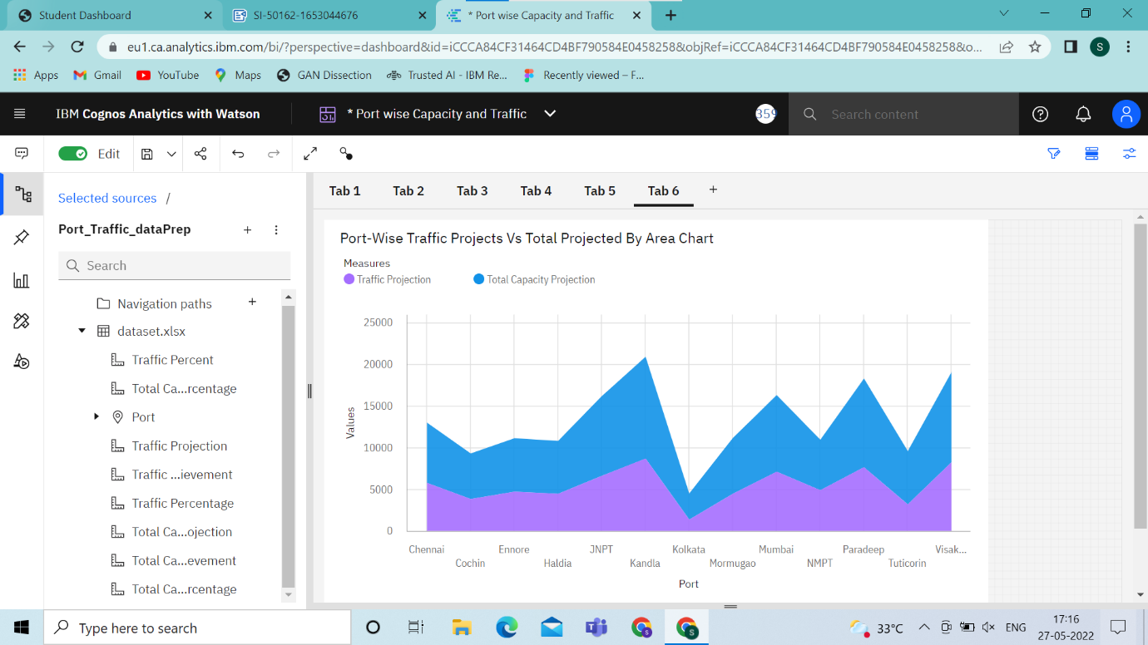

**Port-Wise Total Capacity Achieve, Traffic Achieved Using Stacked Bar**

Linked to the dashboard:https://eu1.ca.analytics.ibm.com/bi/?perspective=dashboard&pathRef=.my_folders%2FPort%2Bwise%2BCapacity%2Band%2BTraffic&action=view&mode=dashboard&subView=model000001810559c660_00000000

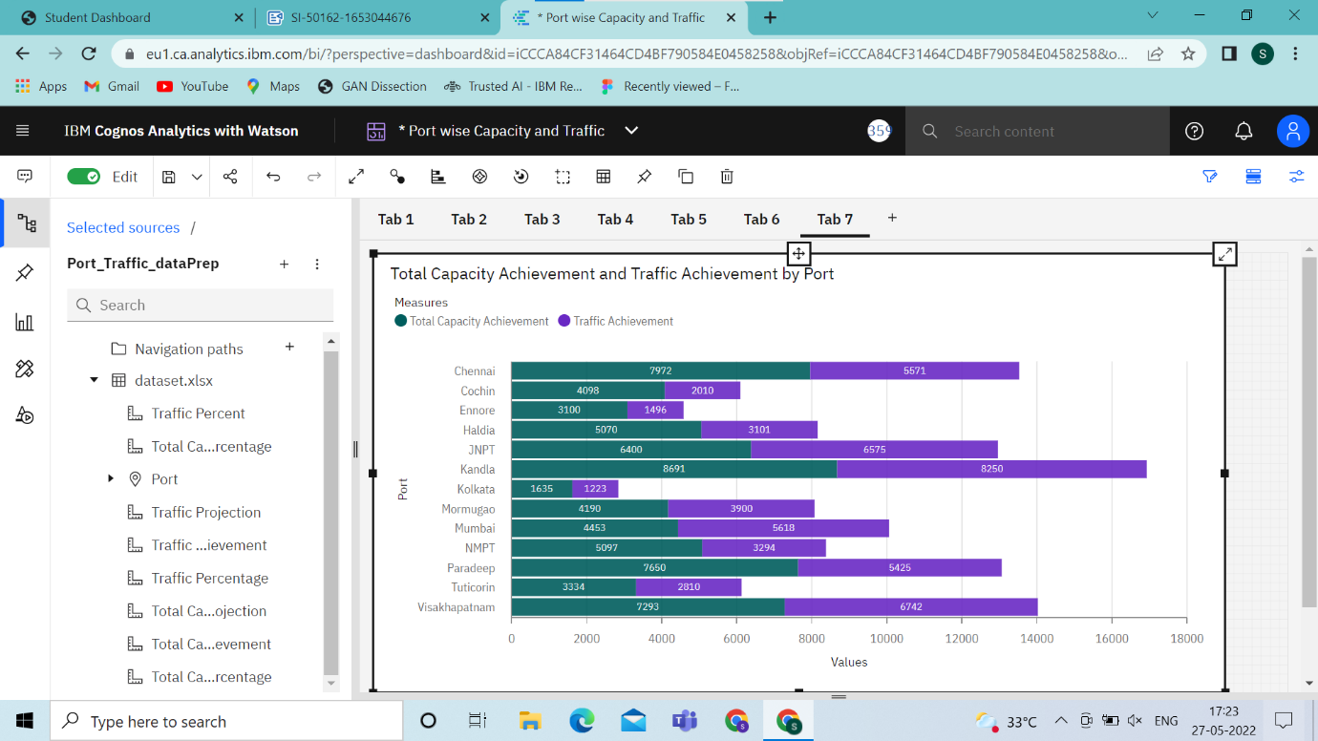

**Port-Wise Total Capacity Achieved Using Map**

**Link to the Dashboard:**https://eu1.ca.analytics.ibm.com/bi/?perspective=dashboard&pathRef=.my_folders%2FPort%2Bwise%2BCapacity%2Band%2BTraffic&action=view&mode=dashboard&subView=model00000181055fabeb_00000000

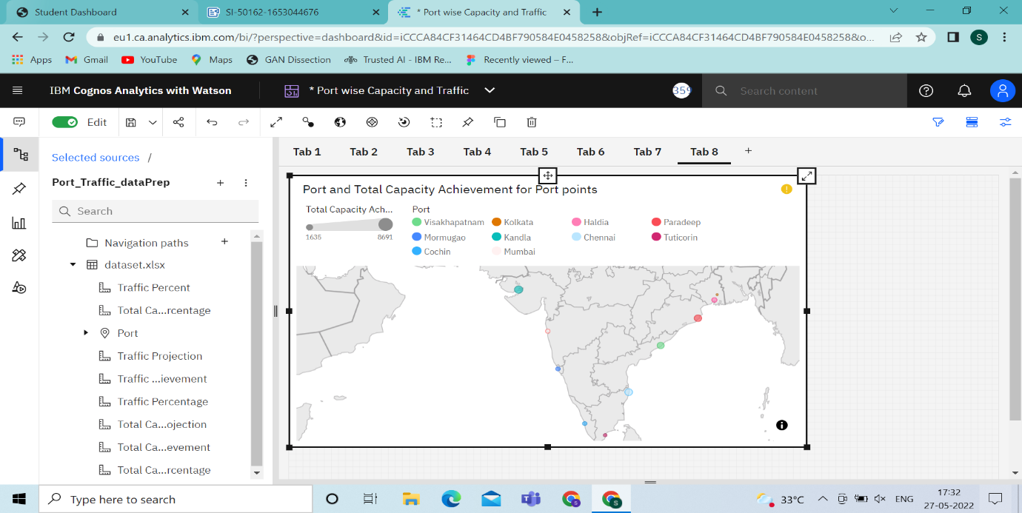

**Filters: by port**

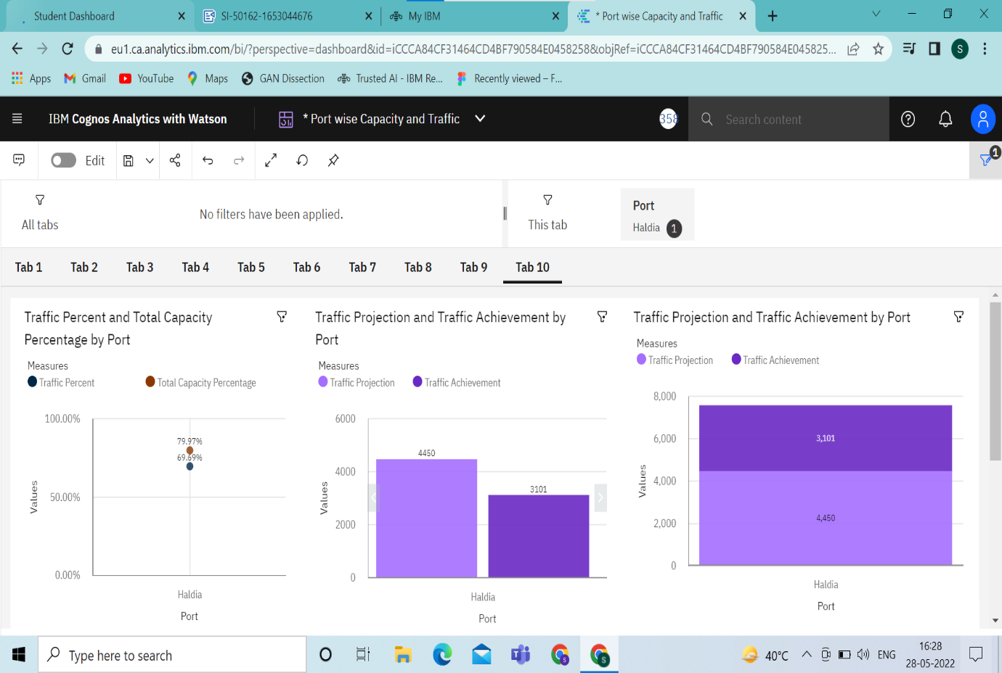

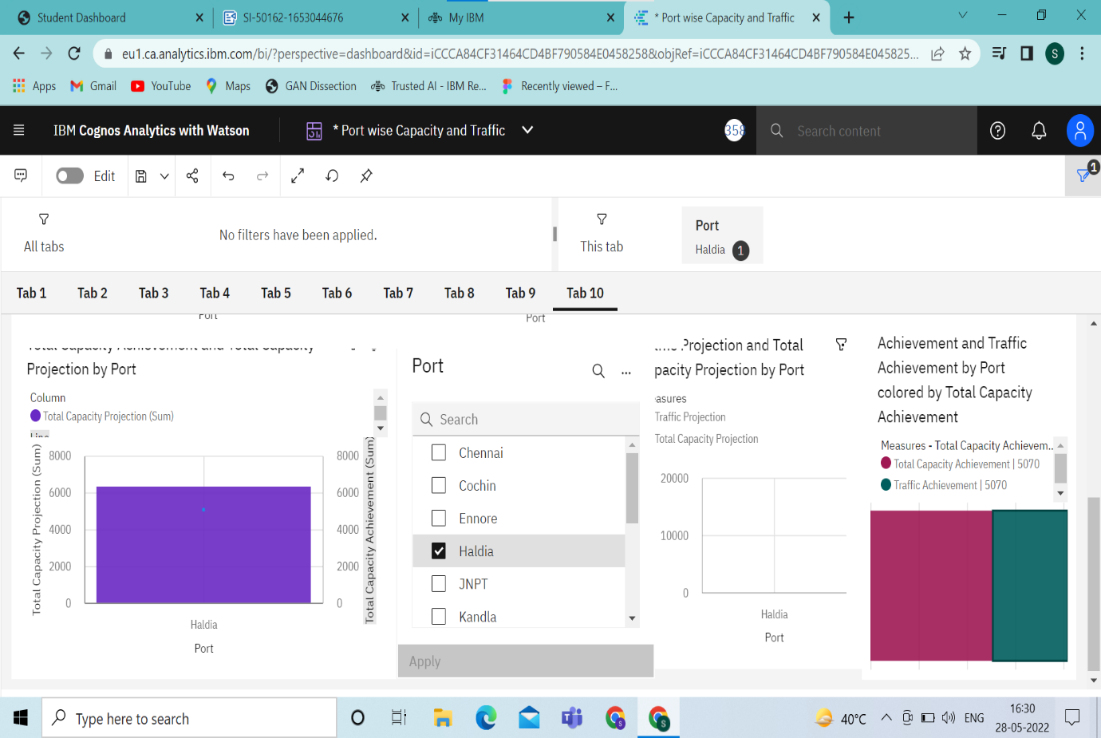

**Summary Cards And Visual Using Total Capacity Vs Actual Capacity Column Chart**

Dashboard link:

<https://eu1.ca.analytics.ibm.com/bi/?perspective=dashboard&pathRef=.my_folders%2FPort%2Bwise%2BCapacity%2Band%2BTraffic&action=view&mode=dashboard&subView=model000001810a0280d1_00000000>

